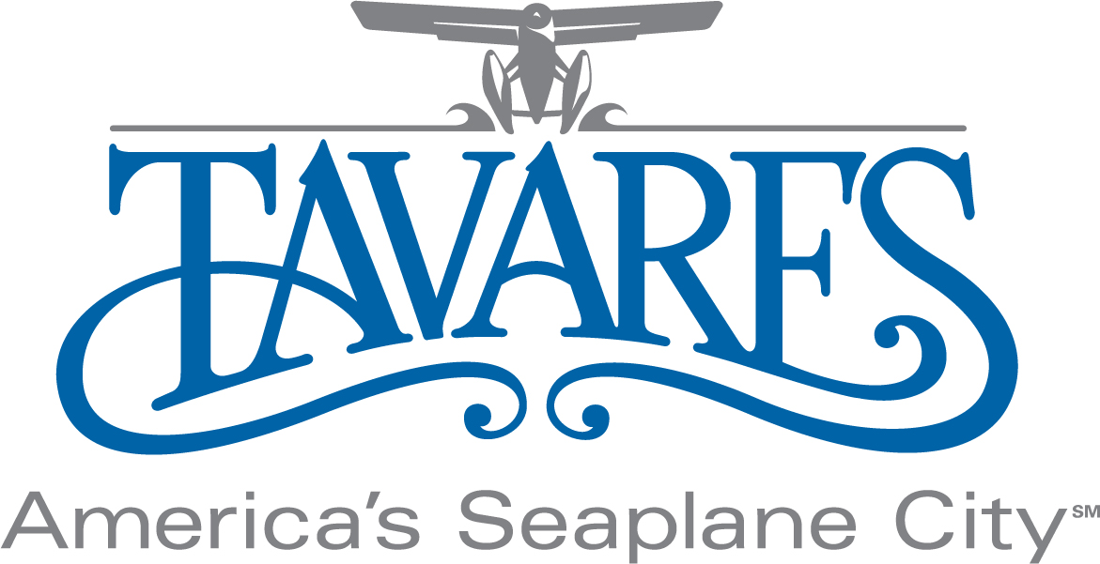

ECONOMIC DEVELOPMENT STRATEGY UPDATE
FEBRUARY, 2019

The Economic Development Strategy is both geographical (see attached map) and component-specific with an emphasis on growing existing businesses and cultivating entrepreneurship. As our existing businesses are the cornerstone and foundation of our City’s economy, providing the fertile ground for these businesses to flourish and for new ones to emerge is the cornerstone and foundation of a sound economic development strategy.

Continued focus and emphasis on fair, reasonable, and transparent regulatory policy and practices that minimize barriers to entry and growth are the most essential elements to this effort. The tagline “Open for Business” is more than a catchy phrase. The City of Tavares is known for being a municipality where business is embraced. City Departments are “user friendly” and the regulatory climate and permitting processes are fair, reasonable, and easily navigated. Maintaining these priorities as guiding principles will continue to make Tavares “a great place to land”.

The components are in no particular order of priority as follows:

- Waterman Hospital Campus
Focus components in this area include the Advent Health, Waterman Hospital Campus located on the Northside of SR441 at the City’s Northeast gateway. Substantial growth is well underway within the approximately 150-acre hospital campus with a new state-of-the-art nursing care facility which opened in 2018 and a new 4 story building currently under construction which will house a new expanded emergency department & woman & Infant department. Plans include the construction of additional medical offices and related support facilities. This campus and its growth and development are key to the enhancement of a vibrant and growing medical village in this sector.

The growth and development of the hospital campus have also stimulated demand for additional residential and mixed-use developments in the surrounding area. As an example, construction of the 240 unit Atwater Apartment complex, the first market-rate, luxury apartment development within the City was completed at the end of 2017 and reached 100% occupancy in the first 6 months. Plans are being developed for the second phase of the complex with another 240 apartment units which are expected soon. Plans are also underway for the development and construction of Avalon Park Village, a mixed-use residential, commercial development. The project is expected to commence with the construction of a charter school in the second half of 2019 with residential and commercial elements to follow in 2020. Build out will be market-driven with multi-year phasing expected.

- Medical Village
The Medical Village Area is centered on the Florida Hospital Waterman campus, on the South Side of 441 for the development of specialized medical offices. As our population ages with the continued onslaught of the “Baby Boomers” generation, the need for quality health care services is essential and the Florida Hospital Waterman area is the natural place for the concentration of health-related facilities and services. The Medical Village continues to grow and expand with new physicians’ offices, surgical, radiology, and imaging centers as well as a new VA. Three new medical buildings are in various phases of construction currently with others in the planning phases.

The growth and expansion of the medical sector within this area will also provide opportunities for the development of casual & quick service dining and retail within this quadrant.

- Downtown Professional Services
Tavares is the County Seat of Lake County and serves as the seat of the 5th judicial circuit. The County Government campus build-out has been completed along with the expansion of the Judicial Center, the construction of a new office building for Constitutional Officers, and the building of a 1,200 space parking garage. With the presence of these institutions along with City Hall on the East end of Main Street, the professional services sector such as legal, engineering & architectural firms, counseling practices, etc. is strong and continues to grow. The City has prudently expanded mixed-use zoning two blocks North of the commercial downtown district along Main Street to Caroline Street and slightly Eastward from Ruby street to the West Side of Disston Avenue allowing for the continued growth and expansion of this important economic component of our community.

- Downtown Entertainment & Business District
The creation of a downtown entertainment district has led to the emergence of a growing population of restaurants and bars offering a variety of dining, music, and entertainment options.

Additionally, the development of a 3 building boutique hotel resort complex with restaurant and other commercial space along with the City’s development of the Pavilion on the Lake have helped to make downtown Tavares a destination. The hotel developer is currently considering additional development options for their final remaining undeveloped parcel adjacent to the Ruby/South Sinclair intersection.

The final remaining component of the County Government seat remaining in the East Main Street section of downtown was removed with the City Purchase and demolition of the former Clerk of Courts Records Center in 2015. The property, dubbed Tavares Square, has been temporarily improved and is serving as a “town square” while being marketed and promoted for re-development consistent with the Tavares Downtown Master Plan.

The Ruby Street Storm-water Improvement and Beautification Project was completed at the beginning of 2019. This project will not only resolve flooding issues within the downtown area while reducing pollutants flowing into Lake Dora but also enhance the attractiveness and vibrancy of this vital downtown waterfront corridor. With its beautiful landscaping, buried utility lines, decorative lighting, and signage fixtures, and ruby red bricks, Ruby Street has become an attractive business and entertainment venue.

The “Beats on The Brick” street party held in January to celebrate the completion of the project was a great success. This very vibrant, energetic event, with music, street buskers, vendors, fireworks, and other elements of entertainment punctuated the Ruby Street corridor as the center core of the downtown waterfront entertainment district. Moving forward into the next fiscal year, a quarterly street party with a similar “Beats on the Brick” theme including elements of entertainment, fireworks, and a “pop up marketplace” with various types of vendors should be considered as an ongoing means of accentuating and enhancing the exposure to this venue and our downtown waterfront entertainment district.

- Commerce Park
The “Lake Ridge Industrial Park” area located in the vicinity of the CR 561 / CR 448 intersection is an active hub of commerce populated with a wide range of manufacturing-related companies from metal fabricators to food processors & distributors. The existing buildings are all at or near full occupancy with several land parcels with industrial use zoning under or available for development on and in the vicinity of the park. Working with existing businesses, property owners, and the newly constituted Lake County Agency for Economic Prosperity to fill remaining vacancies, attract additional companies to develop facilities on vacant land. Re-branding the “industrial park” as a more contemporary and appealing “commerce park” could be a way to help promote the area and attract potential new companies in the contemporary business climate. Development of infrastructure, landscape & aesthetic improvements, and a robust marking program will maximize the potential of this area to attract new companies providing high-skill, high-wage jobs in the manufacturing sector and to grow existing ones. The City’s Seaplane manufacturing impact fee waiver program adopted in June of 2015 is also a valuable tool in attracting new development in this area in the aviation business target sector.

- Marina/Ecotourism/Sports Tourism
Ecotourism and sports tourism are substantial and growing components of the tourism industry within the US and particularly within the State of Florida. With the abundance of lakes, wetlands, and waterways accessible directly from Marina facilities at Wooton Park, Hickory Point Park, and Tavares Recreation Park this market is ripe for growth and expansion within our community. The Wooton Park West enhancement project was completed in the third quarter of 2018. This project has resulted in the construction of two new sand volleyball courts, a triple-wide new boat ramp with a paved parking area, an extension of the Tav-Lee Trail connecting Wooton Park with South Sinclair Avenue and new restrooms will be completed improving upon the public open space with enhanced/cleared shoreline. These improvements which include: 2 new sand volleyball courts; a triple-wide boat ramp with paved parking; a paved multi-use trail along the lakefront; public restrooms; open space/overflow turf parking will support and enhance special events, boating, fishing, kayaking/canoeing, paddle-boarding, and other recreational activities on the Lake Dora waterfront in our downtown attracting additional visitors and residents and enhancing opportunities for our current and future downtown businesses.

The Hickory Point Beach Sand Volleyball Complex is Florida's largest permanent sand volleyball complex with 21 professional sand volleyball courts located at the Lake County Water Authority 68-acre Hickory Point Recreational Complex on Lake Harris in Tavares. Sand volleyball is the fastest-growing NCAA sport in the Nation and the sport is growing in popularity and participation and all levels. This facility hosts major State, Regional, National, and International events and its continued growth and development will have a continued strong, positive impact on our local economy with the thousands of competitors and their families that it brings into our community staying at our hotels, dining at our restaurants and supporting our businesses on an annual basis.

The Big House state of the art sports training and community center is located in the SR 19/561 corridor of the City. This facility developed, owned, and operated by former Major League Baseball player Chet Lemon and his wife Gigi Lemon features 16 indoor volleyball courts, 9 basketball courts, and a host of other amenities and planned improvements to include an indoor major league baseball infield. This facility not only provides sports training opportunities for athletes from the local area and beyond, but hosts numerous athletic tournaments and events throughout the year bringing in thousands of athletes and their families who stay at local hotels, dine at restaurants and patronize our communities businesses. The growth, development, and marketing of this facility are an additional key component of our sports tourism marketing efforts.

- Seaplane Base
The City completed the first phase of construction of the Marina/Seaplane Basin and Marina facilities at Wooton Park in 2010 and has staffed the facility with professionals to manage, operate and maintain the facilities there. The City has also branded Tavares as America’s Seaplane City. The success of the Seaplane base and brand has been well documented with over 20,000 seaplane arrivals/departures since opening in 2010 and its economic impact is evident with the arrival of new hotels, restaurants, and vibrant entertainment district. The based commercial air service provider, Jones Brothers Inc. has grown from a small air tour and flight training operation to include commercial air charter passenger service receiving FAA Part 135 on-demand air taxi certification in July 2015. Passengers can now from the Tavares Seaplane Bases to destinations such as the Bahamas, Florida Keys, and beyond.

Although a devastating blow was struck from Hurricane Irma in September of 2017, insurance coverage is sufficient to complete a rebuild of all of the damaged facilities and enhance/improve upon them, and help prevent future storm damage. The process to rebuild is underway. The Haskell Company has been contracted to complete a design-build project which is currently under design and construction is expected to begin in the second quarter of 2019.

The City also completed an Airport Master Plan in 2017 for the Tavares Seaplane Base (FA1). This is only a handful of Master Plans completed in the State of Florida for an entirely water-based Seaplane Base airport and one of only a few in the entire U.S. The plan includes a long-range capital improvement program that identifies short-term, mid-term, and long-term needs and identifies potential funding sources. This process has also resulted in the Inclusion of the Tavares Seaplane Base i in the Florida Aviation System Plan (FASP) as an airport eligible for State of Florida Department of Transportation (FDOT) Aviation grant funding.

Continued enhancement of the Seaplane Base services, facilities, and experience is an essential component to the continued economic growth and vibrancy of America’s Seaplane City.

- Special Events
The City has distinguished itself as the waterfront event venue capital of Central Florida hosting an average of over 20 annual events at the Wooton Park waterfront, which have a very significant and positive economic impact on the downtown business. Efforts to enhance and grow existing events and develop and attract new ones is a vital part of the continued economic development strategy for the downtown/waterfront sector.

- Arts, Culture & History
Building on the City’s historical ties to the railroad industry, enhancement of railroad infrastructure, and construction of a replica of the Historic Train Depot have been key elements to economic revitalization. The arrival of a growing, vibrant and popular tourist train operation, featuring the official Warner Brothers licensed Polar Express Train Ride for the holiday season, has enhanced the downtown experience and attractiveness. The construction of the historic replica of the original Pavilion on the Lake as the area's premier boutique wedding and private function venue has infused and continues to boost the economic vibrancy of the downtown area as well. The potential development of a performing arts center is being explored through a feasibility study which is expected to be complete by the second half of 2019.

- Highway Commercial/Retail
The City’s “gateway” entrance roadways (SR19, SR441, Old 441, and CR561 & 448) are centers of commerce and commercial development. The development of a new Publix anchored Tavares Crossroads shopping center on SR 19 is complete and 10 to 15 additional new retail and restaurant business will be added in addition to the Publix grocery store within the complex and on adjacent out parcels. The growth and development of additional housing units, including a 1,200 unit planned development of the Shanti Nikettan Phases IV through V1 villages (SR19). The Development of Avalon Park Village (SR 441 Waterman Hospital vicinity) will increase the demand and opportunities for additional retail and related highway commercial growth in these corridors.

As the natural progression of growth/development of residential units occurs in the direction of the ISBA boundary to the Southeast along the S.R. 19 and 448/561 corridors, the potential for an additional small strip mall and related commercial/retail development in these sectors as these business opportunities are driven in large part to numbers of rooftops.

- Quick Service & Casual Dining
This component is a key element to maintaining and fostering an attitude, perception, and feeling of growth and vibrancy. With the dynamic, mobile, and fast-paced nature of our contemporary culture and the variety of options, specialties, and healthy choices available it is the strongest and fastest-growing sector of the restaurant industry and one area in which our City is lacking business growth. Areas of focus for the development of this component are:

- The SR 441 corridor frontage of the Medical Village across from Waterman Hospital.
- The SR 19 Corridor, with emphasis on the 561 intersections in the vicinity of the New Tavares Crossing retail center. In late 2018, the City’s first McDonald’s was opened at this intersection. This will be key to the attraction and development of additional national and regional brand franchises.

- Light Industrial Manufacturing Center
The City’s future boundaries in all quadrants have been defined by the Inter-local Services Boundary Agreement (ISBA). The City’s growth along the old 441 corridors to the East, will include industrial properties which are currently located outside City boundaries and currently serving as centers of light industrial and manufacturing activity. Additional transportation and utility infrastructure improvements (roadway, water, wastewater, and stormwater) will enhance the attractiveness of these properties to new businesses and will allow existing businesses in this area to improve and expand and flourish.

The key to the success of the components is to continue fostering an attitude where the City and its staff are committed to facilitating our existing and new businesses to grow and prosper.

